It's Cool-To-Be-Kind
Show your support with C2BK gear!

Youth Adult
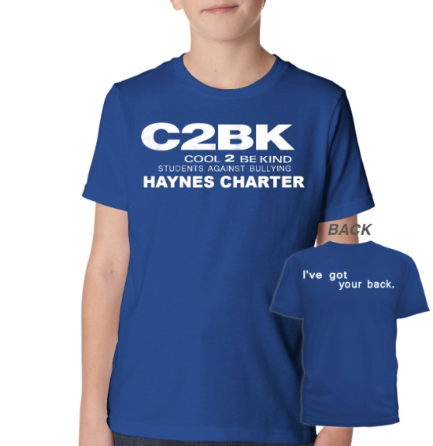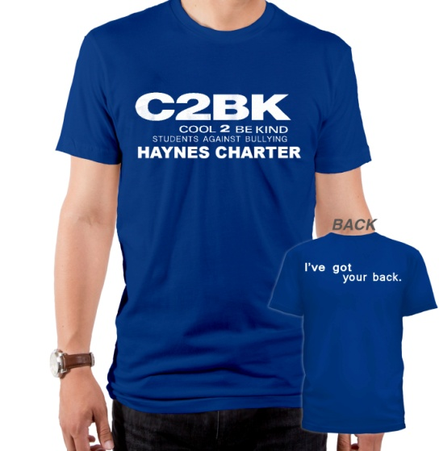

Youth | S | M | L | XL | Qty | $ ea | Total
Blue/White

Adult | S | M | L | XL | 2XL | Qty | $ ea | Total
Unisex Blue/White
*Price: $10 -Cash or check made payable to: Haynes Charter

Student/Name:______________________________________Grade:___________

Room/Teacher:______________________________________________________

Parent Name/Phone:__________________________________________________

